**Assignment 3.5**

1. Import the Titanic Dataset from the link Titanic Data Set.

Perform the following:

a. Is there any difference in fares by different class of tickets?

Note - Show a boxplot displaying the distribution of fares by class

b. Is there any association with Passenger class and gender?

Note – Show a stacked bar chart

#use titanic_train dataset

|  |
| --- |
| > library(titanic)  > boxplot(Fare~Pclass,data= titanic_train,  + main="Fares Versus Pclass",xlab="Fares",ylab="Class",col=topo.colors(3)) |
|  |
| |  | | --- | | > | |

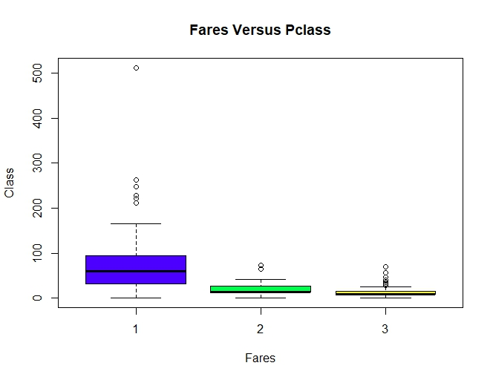

b. Is there any association with Passenger class and gender?

Note – Show a stacked bar chart

> counts<-table(titanic_train$Sex,titanic_train$Pclass)

> barplot(counts, main = "Distribution of Class by gender", xlab="Pclass", col=c("blue", "red"), legend = c("Female","Male"), names.arg = c("Pclass1st", "Pclass2nd","Pclass3rd"))

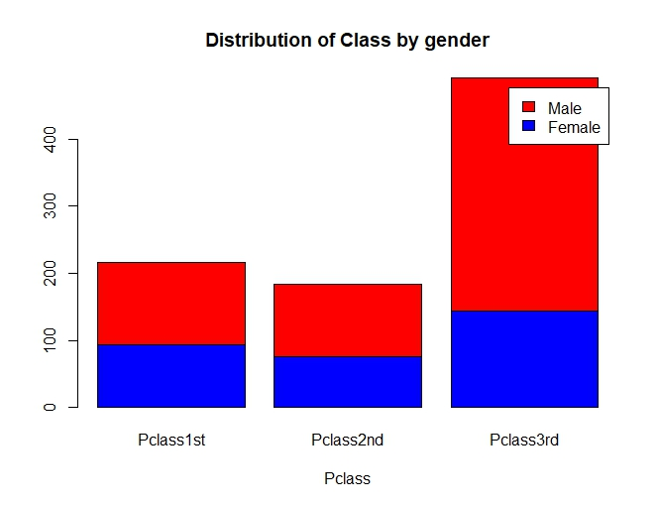

#or like this too

> a1 <- titanic_train$Sex

> a1

[1] "male" "female" "female" "female" "male" "male" "male" "male"

[9] "female" "female" "female" "female" "male" "male" "female" "female"

[17] "male" "male" "female" "female" "male" "male" "female" "male"

[25] "female" "female" "male" "male" "female" "male" "male" "female"

[33] "female" "male" "male" "male" "male" "male" "female" "female"

[41] "female" "female" "male" "female" "female" "male" "male" "female"

[49] "male" "female" "male" "male" "female" "female" "male" "male"

[57] "female" "male" "female" "male" "male" "female" "male" "male"

[65] "male" "male" "female" "male" "female" "male" "male" "female"

[73] "male" "male" "male" "male" "male" "male" "male" "female"

[81] "male" "male" "female" "male" "female" "female" "male" "male"

[89] "female" "male" "male" "male" "male" "male" "male" "male"

[97] "male" "male" "female" "male" "female" "male" "male" "male"

[105] "male" "male" "female" "male" "male" "female" "male" "female"

[113] "male" "female" "female" "male" "male" "male" "male" "female"

[121] "male" "male" "male" "female" "male" "male" "male" "male"

[129] "female" "male" "male" "male" "female" "female" "male" "male"

[137] "female" "male" "male" "male" "female" "female" "female" "male"

[145] "male" "male" "male" "female" "male" "male" "male" "female"

[153] "male" "male" "male" "male" "female" "male" "male" "male"

[161] "male" "female" "male" "male" "male" "male" "female" "female"

[169] "male" "male" "male" "male" "female" "male" "male" "male"

[177] "male" "female" "male" "male" "female" "male" "male" "male"

[185] "female" "male" "female" "male" "male" "male" "female" "male"

[193] "female" "male" "female" "female" "male" "male" "female" "female"

[201] "male" "male" "male" "male" "male" "female" "male" "male"

[209] "female" "male" "male" "female" "male" "male" "male" "female"

[217] "female" "male" "female" "male" "male" "male" "male" "male"

[225] "male" "male" "male" "male" "male" "female" "female" "male"

[233] "male" "female" "male" "female" "male" "female" "male" "male"

[241] "female" "female" "male" "male" "male" "male" "female" "female"

[249] "male" "male" "male" "female" "male" "male" "female" "female"

[257] "female" "female" "female" "female" "male" "male" "male" "male"

[265] "female" "male" "male" "male" "female" "female" "male" "male"

[273] "female" "male" "female" "female" "female" "male" "male" "female"

[281] "male" "male" "male" "male" "male" "male" "male" "male"

[289] "male" "female" "female" "female" "male" "female" "male" "male"

[297] "male" "female" "male" "female" "female" "male" "male" "female"

[305] "male" "male" "female" "female" "male" "female" "female" "female"

[313] "female" "male" "male" "female" "female" "male" "female" "female"

[321] "male" "male" "female" "female" "male" "female" "male" "female"

[329] "female" "female" "female" "male" "male" "male" "female" "male"

[337] "male" "female" "male" "male" "male" "female" "male" "male"

[345] "male" "female" "female" "female" "male" "male" "male" "male"

[353] "male" "male" "male" "male" "female" "female" "female" "female"

[361] "male" "male" "female" "male" "male" "male" "female" "female"

[369] "female" "female" "male" "male" "male" "male" "female" "female"

[377] "female" "male" "male" "male" "female" "female" "male" "female"

[385] "male" "male" "male" "female" "male" "female" "male" "male"

[393] "male" "female" "female" "male" "female" "male" "male" "female"

[401] "male" "male" "female" "male" "female" "male" "male" "male"

[409] "male" "female" "male" "male" "female" "male" "male" "female"

[417] "female" "female" "male" "female" "male" "male" "male" "female"

[425] "male" "male" "female" "female" "male" "male" "male" "female"

[433] "female" "male" "male" "female" "female" "female" "male" "male"

[441] "female" "male" "male" "female" "male" "male" "female" "male"

[449] "female" "male" "male" "male" "male" "male" "male" "male"

[457] "male" "female" "female" "male" "male" "male" "male" "male"

[465] "male" "male" "male" "male" "male" "female" "male" "male"

[473] "female" "female" "female" "male" "male" "male" "male" "female"

[481] "male" "male" "male" "female" "male" "female" "female" "male"

[489] "male" "male" "male" "male" "male" "male" "male" "male"

[497] "female" "male" "female" "male" "male" "female" "female" "female"

[505] "female" "male" "female" "male" "male" "male" "male" "male"

[513] "male" "female" "male" "male" "female" "male" "female" "male"

[521] "female" "male" "male" "female" "male" "male" "female" "male"

[529] "male" "male" "female" "male" "male" "female" "female" "female"

[537] "male" "female" "male" "female" "female" "female" "female" "male"

[545] "male" "male" "female" "male" "male" "male" "male" "male"

[553] "male" "male" "female" "male" "female" "male" "female" "female"

[561] "male" "male" "male" "male" "female" "male" "male" "female"

[569] "male" "male" "male" "female" "male" "female" "male" "male"

[577] "female" "female" "female" "male" "female" "female" "male" "male"

[585] "male" "female" "male" "male" "male" "male" "male" "female"

[593] "male" "female" "male" "male" "female" "male" "male" "male"

[601] "female" "male" "male" "male" "male" "male" "male" "male"

[609] "female" "female" "female" "male" "female" "male" "male" "female"

[617] "male" "female" "female" "male" "male" "male" "male" "male"

[625] "male" "male" "male" "female" "male" "male" "male" "male"

[633] "male" "male" "female" "female" "male" "male" "female" "male"

[641] "male" "female" "female" "male" "female" "male" "male" "male"

[649] "male" "female" "male" "female" "male" "female" "female" "male"

[657] "male" "female" "male" "male" "male" "male" "male" "male"

[665] "male" "male" "male" "male" "male" "female" "female" "male"

[673] "male" "male" "male" "male" "male" "female" "female" "male"

[681] "female" "male" "male" "male" "male" "male" "male" "male"

[689] "male" "female" "male" "female" "male" "male" "male" "male"

[697] "male" "female" "male" "male" "female" "male" "female" "male"

[705] "male" "male" "female" "male" "female" "male" "female" "male"

[713] "male" "male" "male" "male" "female" "female" "male" "male"

[721] "female" "male" "male" "male" "male" "male" "female" "female"

[729] "male" "female" "female" "male" "male" "male" "male" "male"

[737] "female" "male" "male" "male" "male" "male" "female" "male"

[745] "male" "male" "male" "female" "male" "male" "female" "male"

[753] "male" "male" "female" "male" "male" "male" "male" "female"

[761] "male" "male" "male" "female" "male" "female" "male" "female"

[769] "male" "male" "male" "male" "female" "male" "female" "male"

[777] "male" "female" "male" "female" "female" "female" "male" "male"

[785] "male" "male" "female" "male" "male" "male" "male" "male"

[793] "female" "male" "male" "male" "female" "female" "male" "female"

[801] "male" "female" "male" "male" "male" "male" "male" "female"

[809] "male" "female" "male" "male" "male" "female" "male" "male"

[817] "female" "male" "male" "male" "female" "male" "male" "female"

[825] "male" "male" "male" "male" "male" "female" "female" "male"

[833] "male" "male" "male" "female" "male" "male" "male" "male"

[841] "male" "male" "female" "male" "male" "male" "male" "male"

[849] "male" "female" "male" "male" "female" "female" "female" "female"

[857] "female" "male" "female" "male" "male" "male" "female" "female"

[865] "male" "female" "female" "male" "male" "male" "male" "female"

[873] "male" "male" "female" "female" "male" "male" "male" "female"

[881] "female" "male" "female" "male" "male" "female" "male" "female"

[889] "female" "male" "male"

> counts<-table(a1,titanic_train$Pclass)

> barplot(counts, main = "Distribution of Class by gender", xlab="Pclass", col=c("blue", "red"), legend = c("Female","Male"), names.arg = c("Pclass1st", "Pclass2nd","Pclass3rd"))



#we can do chisq test also for checking association

chisq.test(titanic_train$Pclass ,titanic_train$Sex)

> chisq.test(titanic_train$Pclass ,titanic_train$Sex)

Pearson's Chi-squared test

data: titanic_train$Pclass and titanic_train$Sex

X-squared = 16.971, df = 2, p-value = 0.0002064

#ho:there is no association

#since p value is 0.0002064<0.05

#we reject the null hypothesis and thus say there is association